

Foundations of Programming

Lab Assignment No. : 02

PROBLEM STATEMENT:
Write a menu driven program in C to implement the basic arithmetic operations such as Addition, Subtraction, Multiplication, and Division.

OBJECTIVES:
• To understand the concept of menu driven programming in C.
• To apply conditional statements and switch–case control structures.
• To perform basic arithmetic operations using user-defined input.
• To enhance logical thinking and problem-solving skills.

THEORY:
1. if–else ladder statements syntax and sample program
Ans. if(Condition)
{
Body
}
else if(Condition)
{
Body
}
else
{
Body
}
eg. if(5>7)
printf(“5”);
else if(7>5)
printf(“7”);
else
printf(“12”);
- switch–case or if–else ladder statement syntax and sample program.
Ans. switch(n)
{
case 1:
Body
break;
case 2:
Body
break;
default:
Body
}
eg. switch(n)
{
case 1:
printf(“Sum is %d”,(5+7));
break;
case 2:
printf(“Product is %d”,(5*7));
break;
default:
printf(“Invalid input”);
}
Basic arithmetic operations include Addition, Subtraction, Multiplication, and Division. Division by zero should be avoided.

ALGORITHM:
- Start
- Accept the choice of operations for user and store in n
- Accept 2 numbers and store in a and b
- Use switch-case based on n
- If n is 1, perform Addiction and display sum
- If n is 2, perform Subtraction and display Difference
- If n is 3, perform Multiplication and display Product
- If n is 4, perform Division and display Quotient
- If no cases match, display Invalid Input
- Stop

Type Program
#include <stdio.h>
int main()
{
int n;
float a,b;
printf("1.Addition \n 2.Subtraction \n 3.Multiplication \n 4.Division \n 5.Power(x^y) \n 6.Factorial \n");
printf("Enter your choice: ");
scanf("%d",&n);
printf("Enter two numbers: ");
scanf("%f %f",&a,&b);
switch(n)
{
case 1:
printf("Sum is %f",(a+b));
break;
case 2:
printf("Difference is %f",(a-b));
break;
case 3:
printf("Product is %f",(a*b));
break;
case 4:
printf("Quotient is %f",(a/b));
printf("Remainder is %f",(a%b));
break;
default:
printf("Invalid Input");
}
}

PLATFORM:
Linux

INPUT:
Choice of operation and two numbers

OUTPUT:
Displays the result of the selected arithmetic operation
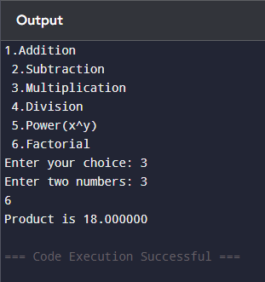
SAMPLE INPUT:
1
10 5

SAMPLE OUTPUT:
Addition = 15

CONCLUSION:
Thus, the menu driven program in C successfully performs basic arithmetic operations using switch–case statements.

FAQs:
1. What is a menu driven program?
2. Why is switch–case preferred over if–else ladder in menu driven programs?
3. What is the purpose of the break statement in switch–case?
4. What is the purpose of the break statement in switch–case?
5. What are the limitations of switch–case compared to if–else?

